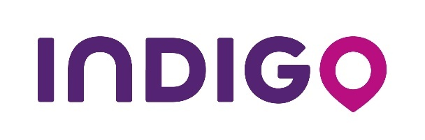
News Wire – 30 April 2019 in Brussels

Indigo inaugurates a new car park
at Brussels South station

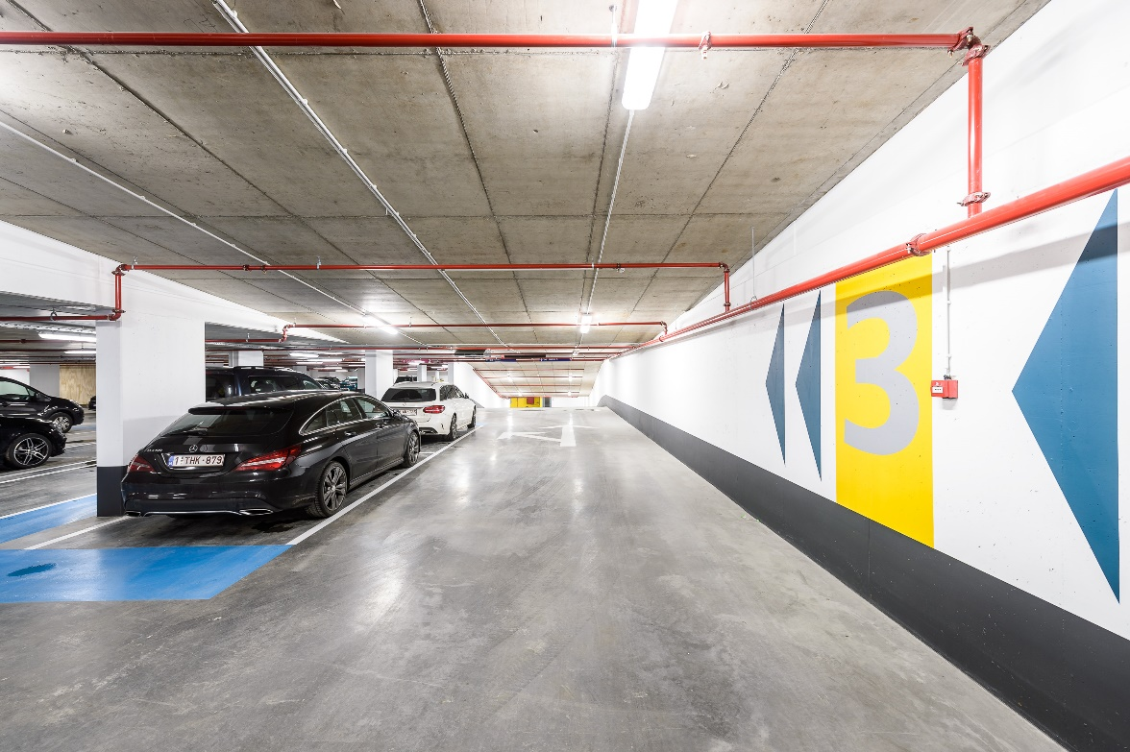

Today, Indigo is opening “Gare du Midi 2” car park, in Rue Bara 101, Anderlecht. Just a stone’s throw from Brussels South station, this new car park has 124 places and enjoys the Indigo Group’s best ability in service quality, comfort and safety.

Beyond its ideal location, the “Gare du Midi 2” car park offers unbeatable rates: 13 € per day or 2.40 €/hour. Also, it is possible for motorists to book their place online www.parking-midi2.be/en/. For each of these bookings, Indigo offers the discount code "midi10" for customers who want to have a 10% discount.

For more than 50 years, the Group has been implementing its off-street car park vision for cities and urban mobility. Indigo invests in modern, welcoming parks, offering intelligent and digitalized services to ease customer experience and mobility in the city. With 75 car parks and over 145,000 places, Indigo is one of the largest car park operators in Belgium.

About Indigo
Indigo is a French group and the world leader for parking and individual mobility. Indigo employs 20,000 people across 10 countries and in over 750 cities.
It is the only parking service operator present on three continents and in all parking segments: on-street, off-street and shared private car parks. Indigo operates more than 5,050 car parks throughout the world, with over 2.3 million parking spaces and over 3,000 km of on-street parking. Indigo provides services to both local authorities and private organisations (hospitals, shopping malls, train stations, airports, universities, etc.) and develops innovative mobility solutions to make it easier for users to get around their cities.
In June 2016, Indigo launched OPnGO, a unique application that offers its users a new parking experience, including a feature that searches for the best itinerary and then the best place at the best price. With OPnGO, the customer experience is based on greater freedom, more choice and personalisation. Drawing on its experience in the field of on-street parking. Lastly, in October 2017, Indigo reached a new milestone with the launch of INDIGO Weel, thereby becoming the only French company to offer a station-less self-service bike-sharing system. This service is aimed at all the countries in which the Group operates.
Indigo is a global player with a local presence. In a booming mobility market estimated to reach €100bn by 2025, Indigo is a key player as far as the mobility of the future is concerned. INDIGO. Making space for the future.
www.group-indigo.com

Press contact:

France - Rumeur Publique
Aurore DUPUY - 06 78 52 70 97
Indigo@rumeurpublique.fr

Belgique – Indigo Group
Dylan BOLS - +32 478 24 95 67
dylan.bols@group-indigo.com

